TO220 Package RTP30 Thick-Film Resistor

- The RTP30 thick-film non-inductive power resistor, also known as a TO220-packaged high-power resistor, utilizes the TO220 package form factor—a common through-hole package type for high-power transistors, medium-to-small-scale integrated circuits, and power resistors.
- The RTP30 resistor is rated at 30W. It is used in power supply input stages,low-energy pulse loads, RF power amplifier terminating resistors,voltage rectifiers,buffer circuits,UPS systems, and similar applications.

➢

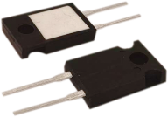

Technical Specifications

Rated Power | Insulation Resistance | Maximum voltage | Output terminal | Insulation Withstand Voltage
30W | ≥10GΩ | 500VDC | Tin-plated copper wire | 2000VAC
Resistance range | Operating Temperature | Optional precision | TC | Installation torque
0.1Ω— | -55℃— | ±0.5% | ±100 | M3/  0.9mN
1MΩ | +170℃ | ±5% | ppm/℃ | M3/  0.9mN

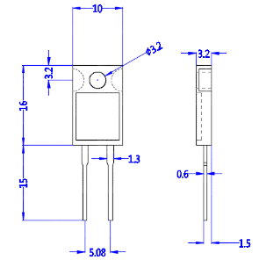

Performance
Test Item | Perf Req | 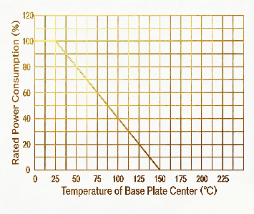  Test Standard
Overload | ΔR≤±0.25%R | 1.5P rated power not exceeding 1.5Umax, 5s
Lifetime | ΔR≤±1%R | 2000h at rated power  Steady-State Humidity and Heat
Steady-state humid heat | ΔR≤±0.25%R | MIL-Std-202,Method 103, Condition D
Thermal shock | ΔR≤±0.3%R | -65 to 155°C, 5 cycles
High-frequency vibration | ΔR≤±0.2%R | MIL-Std-202, Method 204, Condition D
Lead strength | ΔR≤±0.2%R | MIL-Std-202, Method 211, Condition A

